**Type the Title of Your Paper, Capitalize Each Word**

**A. Firstauthor**1\***, B.C. Secondauthor**2**, D. Thirdauthor**1,2

*1First affiliation, Address, City and Postcode, Country*

*2Second affiliation, Address, City and Postcode, Country*

**A R T I C L E I N F O a B S T R A C T**

|  |  |  |
| --- | --- | --- |
| **IJOCS use only:**  Received date  Revised date  Accepted date  *Keywords:*  Supply some 4–5 keywords  Keyword1  Keyword2  ... |  | These instructions give you guidelines for preparing papers for International Journal of Community Services (IJOCS)*.* Use this document as a template using Microsoft *Word* 6.0 or later. The electronic file of your paper will be formatted further at IJOCS. Abstract should be no longer than 300 words, giving a brief summary of the content and conclusions. Do not include artwork, tables, elaborate equations or references to other parts of the paper or to the reference listing at the end.  © 2025 International Journal of Community Services. All rights reserved |

**Introduction[1]\***

State the objectives of the work and provide an adequate background, state of the art, avoiding a detailed literature survey or a summary of the results. Reference numbers should be indicated in the text by square brackets, e.g. [1], or [1,3], or [1-3].

**ExperimentAL Method**

Provide sufficient detail to allow the work to be reproduced. Methods already published should be indicated by a reference. Only relevant modifications should be described.

**results and discussion**

Results should be clear and concise. Discussion should explore the significance of the results of the work, not repeat them. A combined Results and Discussion section is often appropriate. Avoid extensive citations and discussion of published literature.

IJOCS will do the final formatting of your paper, so you do not need to position figures and tables at the top and bottom of each column. In fact, all figures, figure captions, and tables can be at the end of the paper. Large figures and tables may span both columns. Place figure captions below the figures; place table titles above the tables. In case there is any difficulties to arrange the figure(s) and Table(s) in appropriate place, they can be placed at the end of this template.

Amount of 128I (amol)

Time (min)

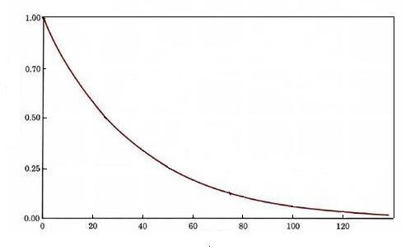

**Fig. 1.** Radioactive decay for 128I.

Equations

Conventionally, in mathematical equations variables and anything that represents a value appear in italics. You may choose to number equations for easy referencing. In that case the number should appear at the right margin.

**Table 1.** Radioactive isotope decay

|  |  |  |
| --- | --- | --- |
| Isotope | Half life | Particle Emitted |
| 32P | 14.3 days | ß |
| 33P | 25 days | ß |
| 14C | 5,730 years | ß |
| 3H | 12.3 years | ß |
| 35S | 87.4 days | ß |
| 125I | 60 days | γ |

**conclusion**

A conclusion contains the main points of the article. It should not replicate the abstract, but might elaborate the significant results, possible applications and extensionns of the work.

**ACKNOWLEDGMENT**

Acknowledgment is recommended to be given to persons or organizations helping the authors in many ways. Sponsor and financial support acknowledgments may be placed in this section. Use the singular heading even if you have many acknowledgments.

**references**

1. S.D. Glazek and K.G. Wilson, Phys. Rev. D **57** (1998) 3558.
2. P. Maass, W. Dieterich and F. Scheffler, AIP Conf. Proc. **832** (2006) 492.
3. K. Basar, T. Sakuma and E. Kartini, *Frequency and Temperature Dependent of Conductivity from Superionic Conducting Glass (AgI)x(AgPO3)1-*x, Proceedings of the International Conference on Mathematics and Natural Science (2006) 881.
4. W.S. Lyon, Guide to Activation Analysis, 2nd ed., Van Nostrand Co. Inc., New York (1960) 33.
5. M.F. Collins and E. Kartini, *Superionic Conduction in Silver Oxysalt-Silver Salt Glasses*, Recent Research Development of Solid State Ionics Vol. I, S.G. Pandalay (Ed.), Transworld Research Network, India (2003) 167.
6. D.L. Davids, Recovery Effects in Binary Aluminum Alloys, Ph.D. Thesis, Harvard University (1998).
7. M.B. Hegner and K.L. Wendt, *Method of Sorting Seeds*, UK Patent 1470133 (1977).

**Please be sure that the manuscript is up to date. Reference minimal its 12 reference. It is expected that 20 to 30% of references are to recent papers.**

1. * Corresponding author.

   E-mail address: type your email address here